A close up of a piece of paper

Description generated with high confidence

Ninong & Ninang

Ray Joseph O. Alejandro

Charlie Orquita

Nelvie Orquita

Margeme M. Guillen

Lovie Joy Guillen Caruyag

Melcha Joy Laurente

Joseph Condontol

Cosme Resula

Luzviminda Orillaneda

Judith Ganancias

Mylen Aruyal

Kisha Laid

Leonisse Kate Tocmo

Mark Vincent Arnaldo

Prince James Arriesgado

Seberino Arriesgado Jr.

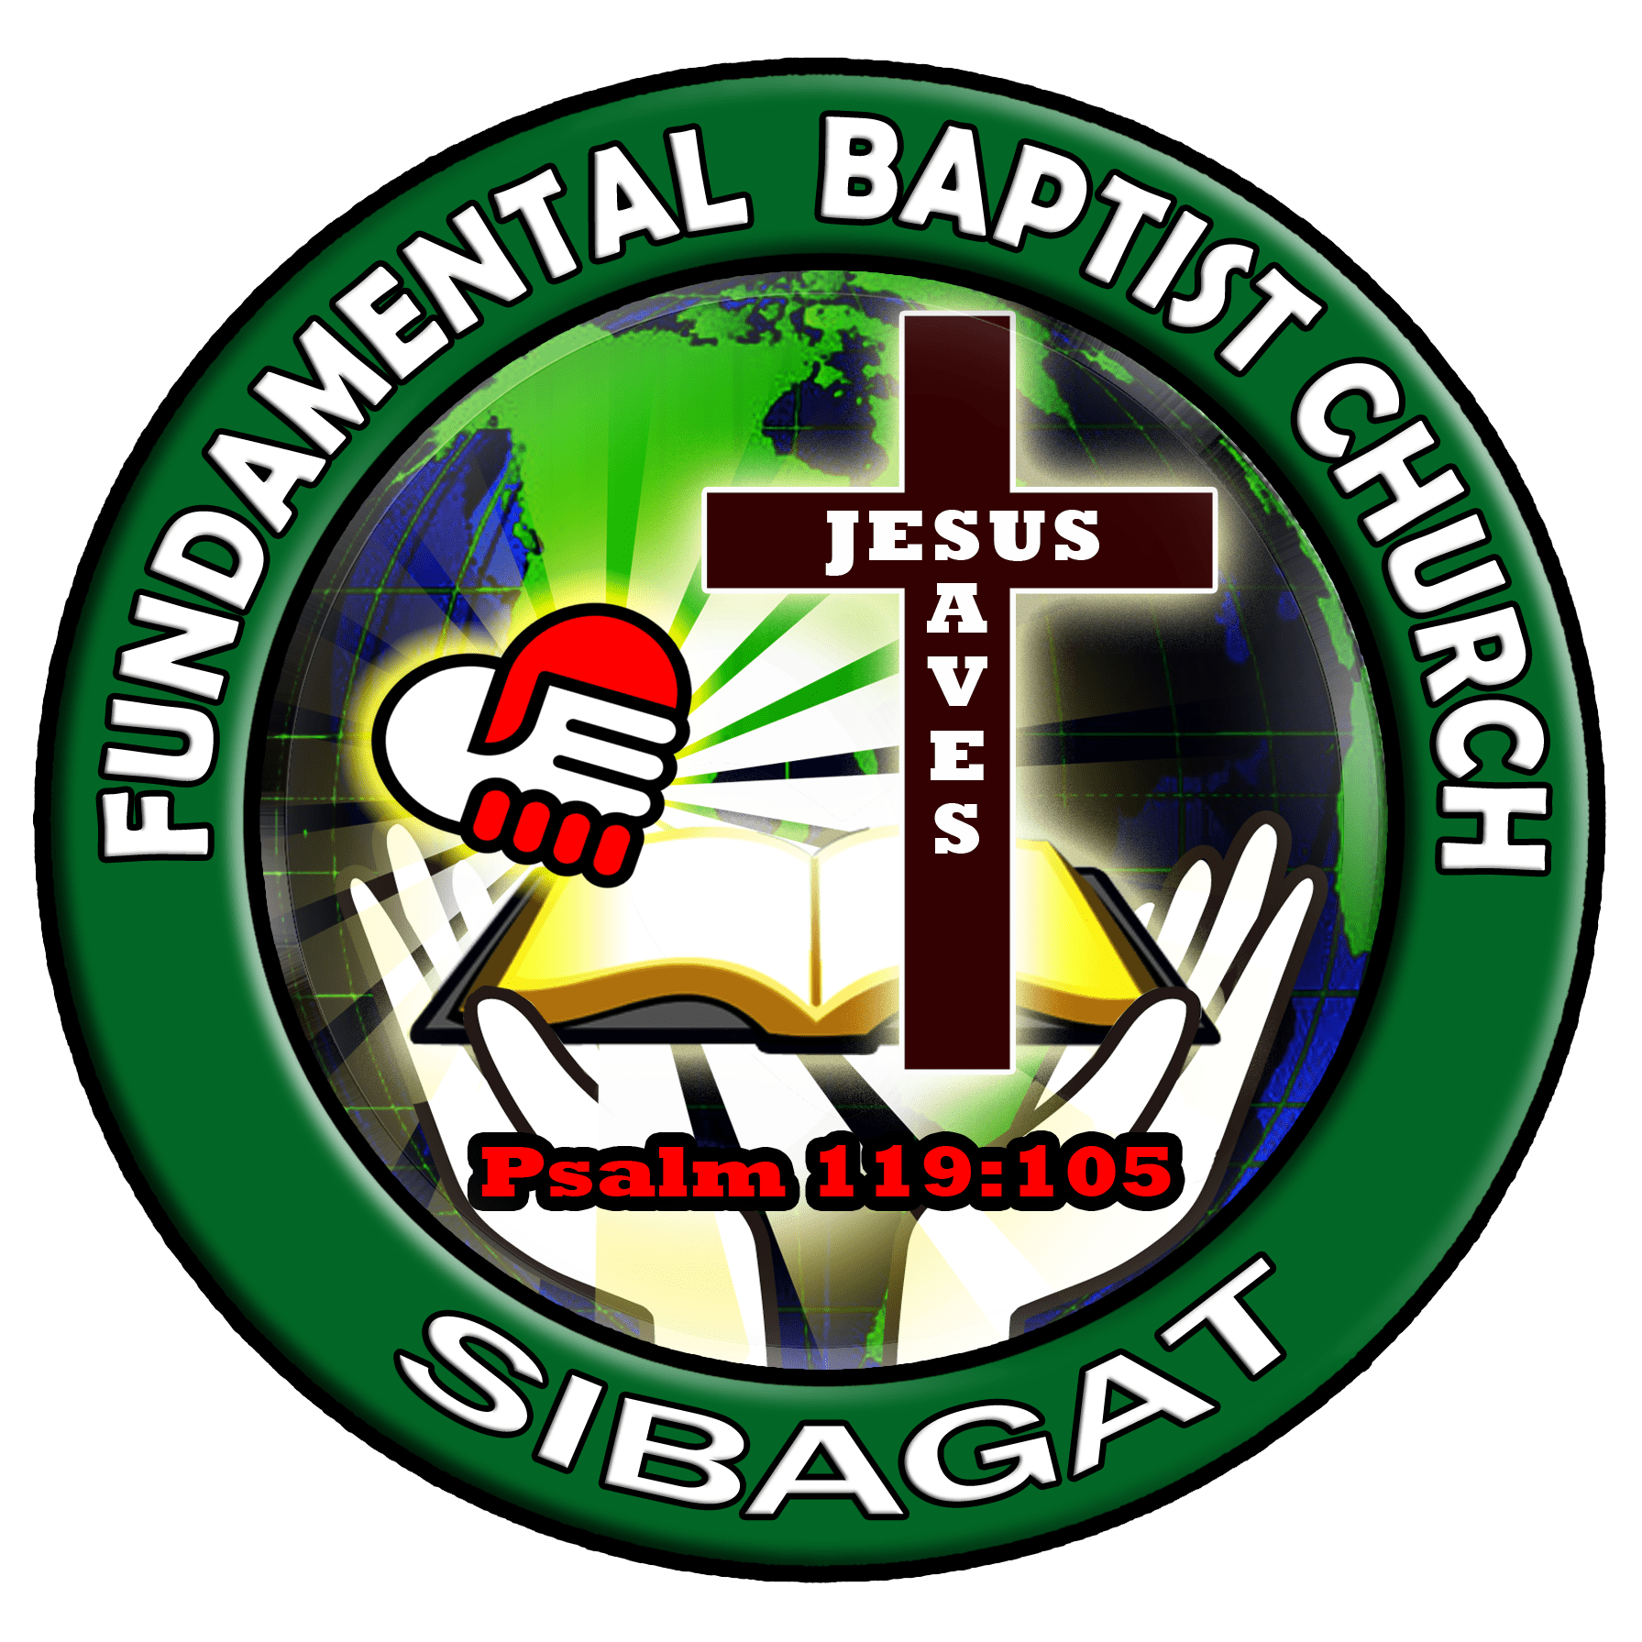



*"Children are a heritage from the Lord, offspring a reward from him.".*

*Psalm 127:3*